Walk 19 North Titley
Last walked in September 2017

Description. A 5 km (3.1 mile) moderate walk up and down a hill.
Start. Explorer Map 201 Grid 335604.
Direction from Whitecross roundabout (Turn milometer to zero). Take the A4111 to Kington. At 18.2 miles go straight across first roundabout, heading towards Rhayader on the A44. At the second roundabout (18.6 miles) TR onto the B4355 to Presteigne. At 21.6 miles, park in the layby that’s across the road and just before reaching the church in Titley.

1. St Peter’s Church. The Parish church of St Peter dates from 1865 and is built on the site of a former priory for a branch of the Benedictine Order. Titley lies at the junction of two drover's roads and was used for the weighing of wool. Walk along the road and just past the church on your L, TL up a public footpath signed Circular Walk, (the Circular Walk route is what we are following). Go thru a metal gate in front of you and continue on up an enclosed track, keeping to the hedge/tree line on your R hand side. Ignore the first kissing gate on your L and continue up hill to the next kissing gate in front of you, which you go thru into F2, (ignore the enclosed track that goes R then L). Keep to the R field edge and near to the top of the hill, when the hedge on your R turns R, you go straight on ahead, to cross the field and go thru double kissing gates into F3. Cross this field, bearing slightly R of the L hand edge, to go thru another gate into F4. Start to descend as you cross this field to go thru another gate into F5, (Green Lane Wood is over on your R hand side). Continue in the same direction, under electric cable, and cross over a stile that’s to the R of a gate and into F6. Keep to the L edge of the field and pass the farm buildings that are on your L, to cross over a stile.

2. Green Lane Farm. TL and after a few paces you TR and walk along a tarmac/dirt lane, (green Lane). Go thru metal gates and continue on towards Wychmoor Farm. Further on you pass a farm cottage on your R and go thru a gate onto an enclosed overgrown grassy lane, then on thru another gate and continue along an enclosed dirt track lane for almost a kilometre, going thru another two gates on your way along the lane. Just past an old stone, corrugated iron roofed farm building that’s on your L, and at a wooden signpost, you turn sharp L and head towards Titley 1½ miles, along an enclosed track.

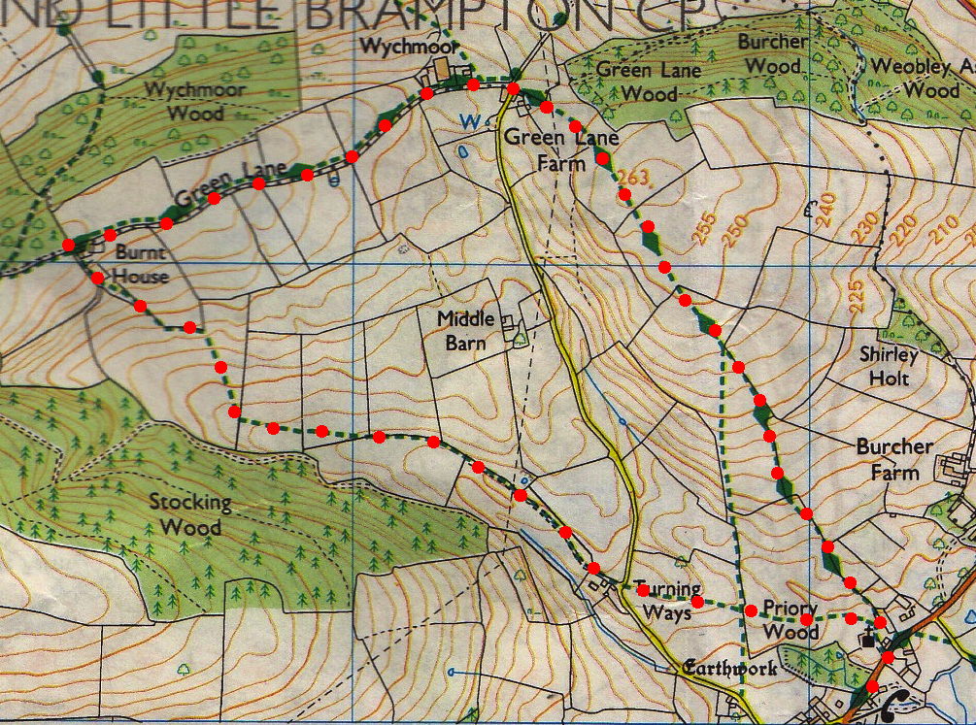
3. Burnt House. Follow the Circular Walk way markers downhill and along an indistinct track. Go thru a small metal gate and into F7 on your R, then continue along the L field edge. Beautiful scenic views as you walk along. Go thru a gate into F8 and keep to the L edge for 80m, and at the hedge corner by a way marker post you turn diagonally R and continue on down to go thru a kissing gate into F9, (the gate isn’t far from the bottom of the field). Go straight across this field, keeping parallel with Stocking Wood on your R to go thru another kissing gate into F10. At the end of F10, in the bottom R hand corner, you TR into F11, and then TL to walk along a farm track, a hedge is on your L. Continue along farm track and go thru a metal gate and along an enclosed track to reach a road by a farm house at Turning Ways. Cross over the road, and then cross over a stile into the field ahead. Don’t loose or gain height while you cross this field and go thru a gate into another field. Head to the L of the church and surrounding buildings and cross over a stile, then go thru a metal gate and TR, to head down to the main road where you TR for the car.
2
3
1

